Keegan Millington

27042007

Cover Page

Keegan Millington

Keegan.millington@gmail.com

Abstract

Determine the requirements of a (web) project and be able to display the  
information collected from a brief into a description that can be used to  
create some mock ups for the final product.

# COMP.5209 - Interface Analysis and Design

Assignment1

# Brief

In this Assignment one I was asked to Create a flowchart of the idea of creating a web page for the Toi Ohomai Cafe. I was to Create a rich picture that compliments your flow diagram. Write a small report (max 1000 words) on how the two design principles can be implemented in this project. Find and select 2 web frameworks that would work in well with the café web page.

# Task 3: PACT - People Activity Context Technology

The people using this website would be the students, the staff working in the cafe and the tutors of the Toi Ohomai Rotorua campus. The reason that I think these people would be the ones using this website more than others is that it's the closest cafe or any form of food close to the polytechnic which means that it is the easiest form of way of getting food. Another reason why I think these people would be using this website more is because of the location of the cafe it’s inside the campus making it hard for outside to access. The PACT analysis is a way of reflecting on people, activities, content and lastly technology. The function of the Cafe is to allow customers/people to view what products are left in stock which is done by the weight of each product, for example, each product is weighted and put in the heater or fridge. There will be scales underneath the food letting the staff know how much food is left. The scale is then programed to the website so the food will pop up on the website allowing customers to see how much product is left before having to go down and check. The main devices that will be using this website would be cell phones. The reason it would be cell phones is that more people have and use cell phones than computers. It would make it a lot more accessible to use if the website was created for both cell phones and computers. The reason for that is there are a lot of onsite computers that students can use when they want. The average age for a student is 23 so you would expect a 23 year old to have a cell phone.

Map For the Café bellow…

<https://toiohomai.ac.nz/sites/default/files/inline-files/new%20campus%20maps_2019_green%20TGA.pdf>

# Task 4: Selecting Framework

1st Framework (Spring)

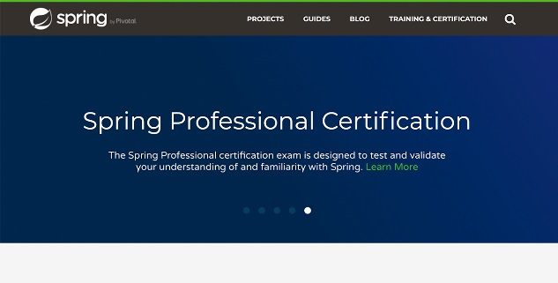

Spring is the most popular app development framework for JavaScript. Spring is well known for their high performance strong web apps. This is a positive for the website as the website will new an app that runs smoothly and reliable. A negative about this framework is that it specialises in making app support better and the website also needs a web page so this framework won't be any good to use for making the page. The framework is highly secure.

2nd Framework ([Asp.net](https://www.asp.net/))

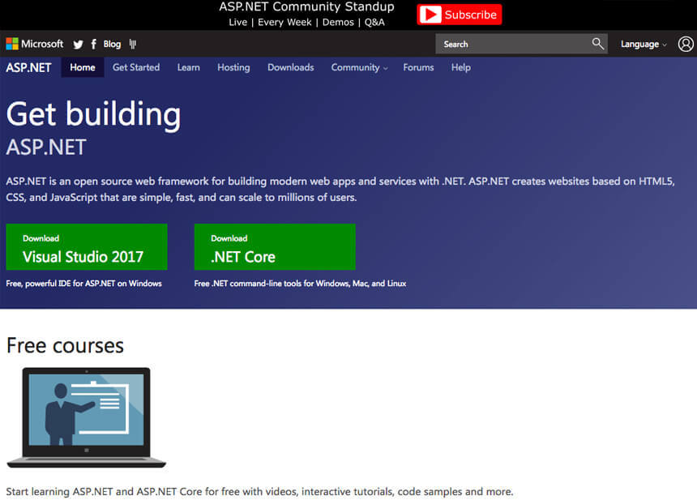

Asp.net is a popular framework that was established in the year 2002. Asp is able to create rich and dynamic websites/web pages. This is a positive for the website I’m creating because Asp.net will be really useful as I will need to create a webpage that looks fancy attracting the customers. Another positive is this framework reduces the coding time. A negative about this framework is that Limited support for testing and SEO making this framework hard for testing.

Documentation: A photo of the html code.

<https://dotnet.microsoft.com/static/images/screenshot-razor-editor-vs.png?v=1ucG7ya4I12-ajagHXoqxPhkOhhiGQWN7k_xPkirbIY>

# Task 5: Format Document

Table of Contents

COMP.5209 - Interface Analysis and Design 0

Brief 1

Task 3: PACT - People Activity Context Technology 1

Task 4: Selecting Framework 1

Task 5: Format Document 2

References 3

27042007-Assessment1-Task1 4

27042007-Assessment1-Task2 5

# References

1. Aasif. (2019, September 2). Top Web Development Frameworks for 2019-20. Retrieved from <https://www.appypie.com/top-web-development-frameworks>
2. Retrieved from <https://dotnet.microsoft.com/static/images/screenshot-razor-editor-vs.png?v=1ucG7ya4I12-ajagHXoqxPhkOhhiGQWN7k_xPkirbIY>
3. spring.io. (n.d.). Retrieved from <https://spring.io/>
4. ASP.NET. (2002). Retrieved from <https://dotnet.microsoft.com/apps/aspnet>
5. What is .NET? (2002). Retrieved from <https://dotnet.microsoft.com/learn/dotnet/what-is-dotnet>
6. Vivienne Trulock. (2005, August 12). PACT Analysis. Retrieved from <http://hci.ilikecake.ie/requirements/pact.htm>
7. Vivienne Trulock. (2005, August 12). PACT Analysis Example 1. Retrieved from <http://hci.ilikecake.ie/requirements/pactexample1.htm>

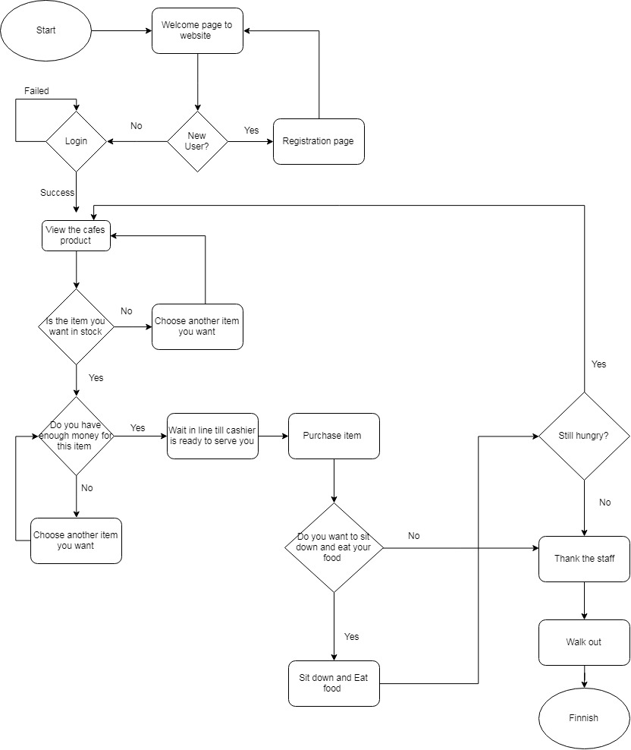

# 27042007-Assessment1-Task1

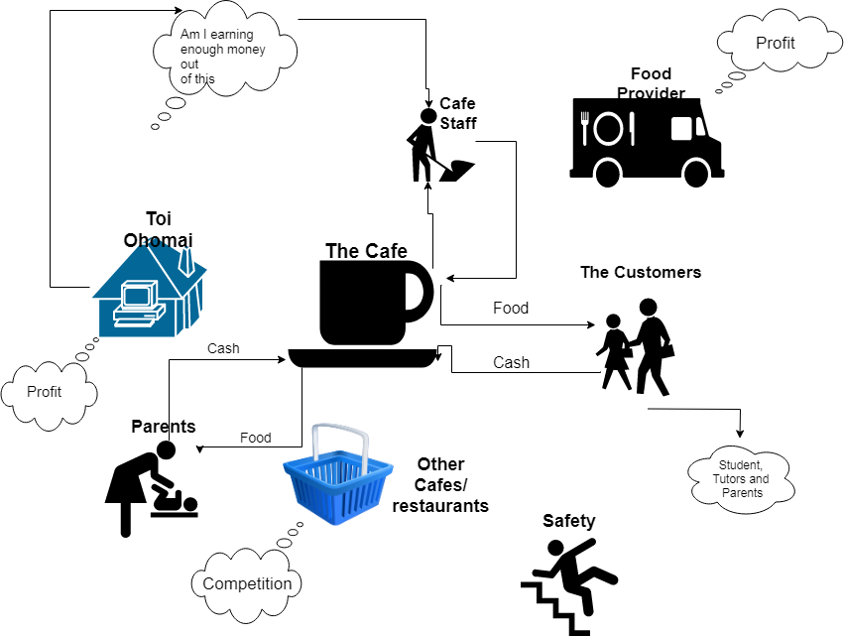

# 27042007-Assessment1-Task2

# COMP.5209 Interface Analysis and Design Assignment 2

# Task 1: Design Sketches

Create 3 sketches of ideas for your website. The sketches should be for a Desktop layout only and be very low in detail. The idea is to show that you have thought about different layouts for your website. You will then need to write up a small paragraph (about 100 words) on the decision for your choice. Write the pro’s and con’s for each design.

I have chosen these three designs one for each page (Home, Menu, Contact us) because I believe it's simple to understand so the user can find what they are looking for at an efficient rate. The others were not chosen because it didn't look tidy and it was hard to understand.

The pros about theses sketches are there is only three pages making it easy to find what you're looking for. Another pro is the logo, title, buttons and google map address are in the exact place on each sketch so it doesn't confuse the user when changing pages. A con is that there isn't much to it as it is only a cafe not much information needed

Home...

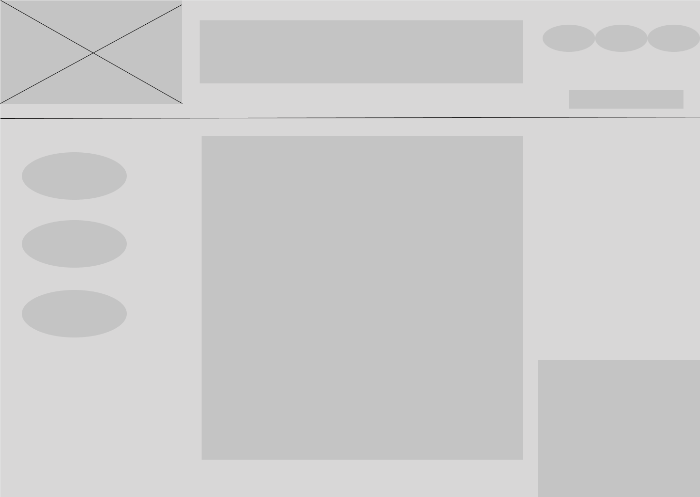

Menu...

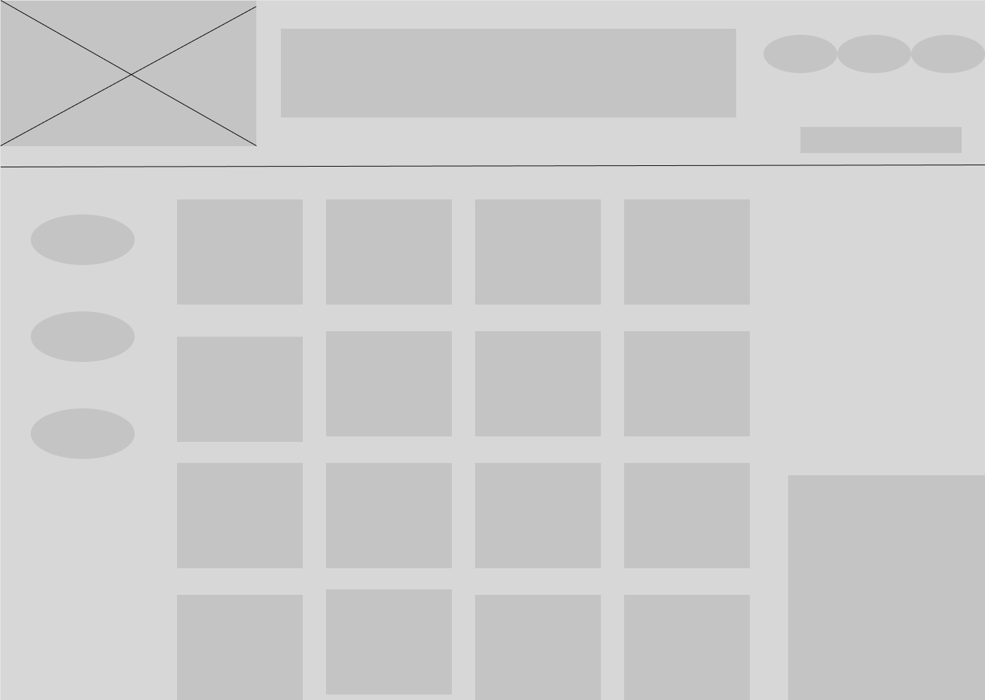

Contact us..

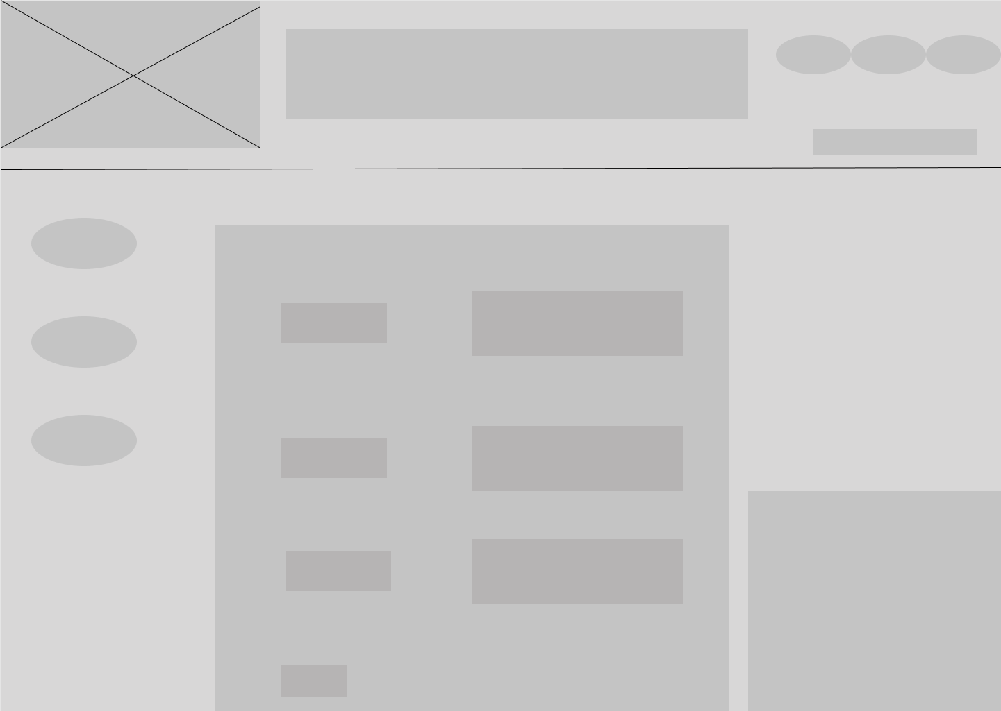

# Task 2: Low-Fidelity wireframe (25 marks)

Create a low fidelity wireframe in Figma (or similar tool) for every page that you have created in your flow chart of Assignment 1. Account for all the user stories of your assignment 1 brief. Create designs in 3 different sizes for each page. (mobile phone, tablet and desktop) Use the following sizes to make your wireframes: • Mobile Phone (Portrait) 320 x 568 pixels • Tablet (Portrait) 768 x 1024 pixels • Desktop (Landscape) 1440+ pixels Note that this does not cover all sizes for a full design, but it still forces to think of 3 specific layouts for each device.

Desktop - Home

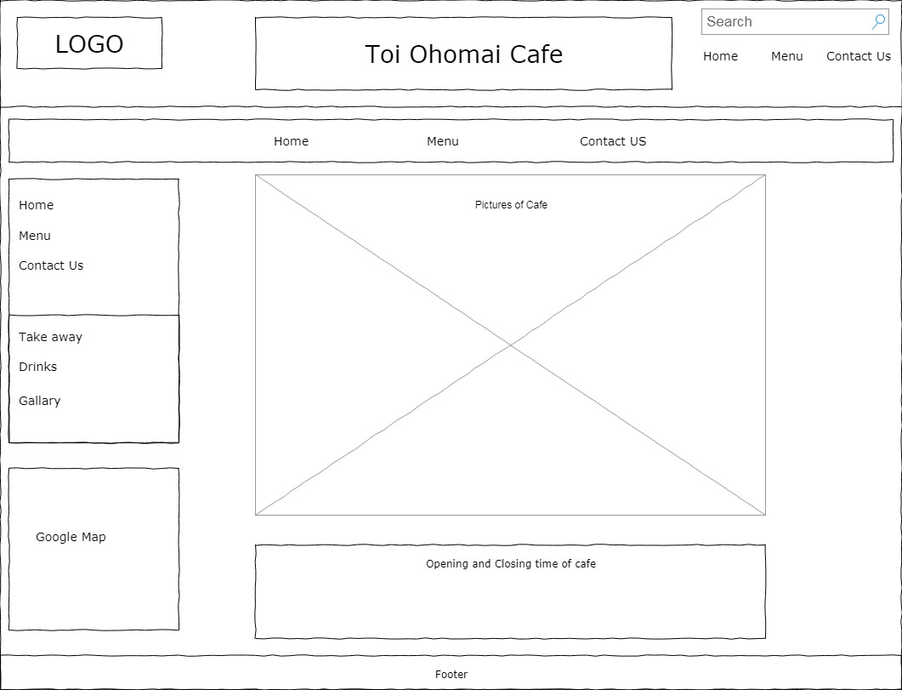

Desktop - Menu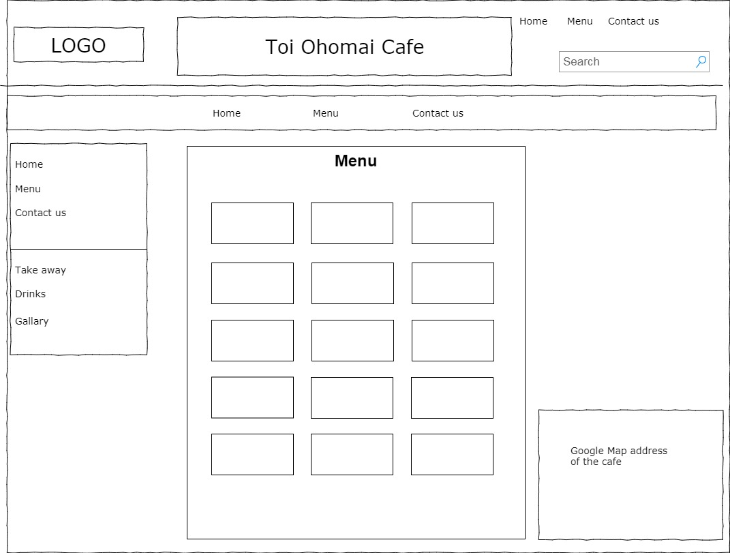

Desktop - Contact us

# https://lh3.googleusercontent.com/pJ5U-I5ODPAz4pA-8Mg94j9FrhRR8WlH18RCJMWFLaDhA4z5f8MiMPYq_W64RvLl3QuLt24Hm-LmZyvYsmNfq5z-qsvNl8gs_JQ2IpuMGkWm57nX6GPMjqEKs1vY0iwIdOnkOx-h

Mobile Phone - Home Page

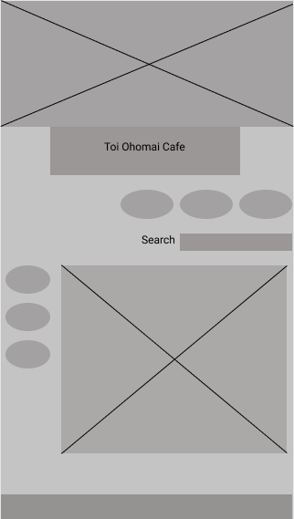

Mobile Phone - Menu

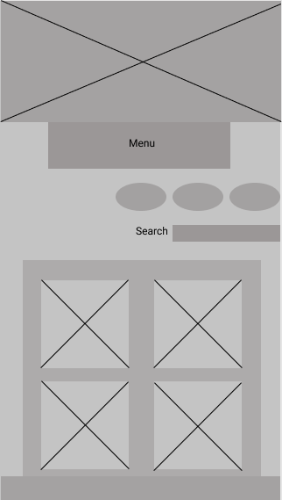

Mobile Phone - Contact Us

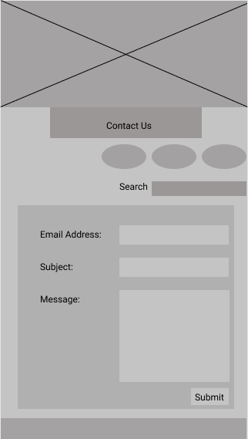

# Task 3: High-Fidelity wireframe (20 marks)

Using the same specifications as from Task 1, create a High-Fidelity Wireframe that shows much more detail of your product. You are able to use colours and writing in this mock up. You are to use any images on this design that you want to use in your final website.

Home Page - Desktop High- fidelity wireframe

# https://lh5.googleusercontent.com/C3pDnDfieZHyavmdAqUsIRVo9Hg5xtdB2gw9mI3hcxJ1jCmDFVAo-qSwHU3BrzthZemX9xutUEQFBrO9sAZJnVjkJiA_ijcvrKPh1k2sEKpbsg0Ocb-4GraAI5yNF-Ha9s3sZLxW

Contact Us - Desktop High- fidelity wireframe

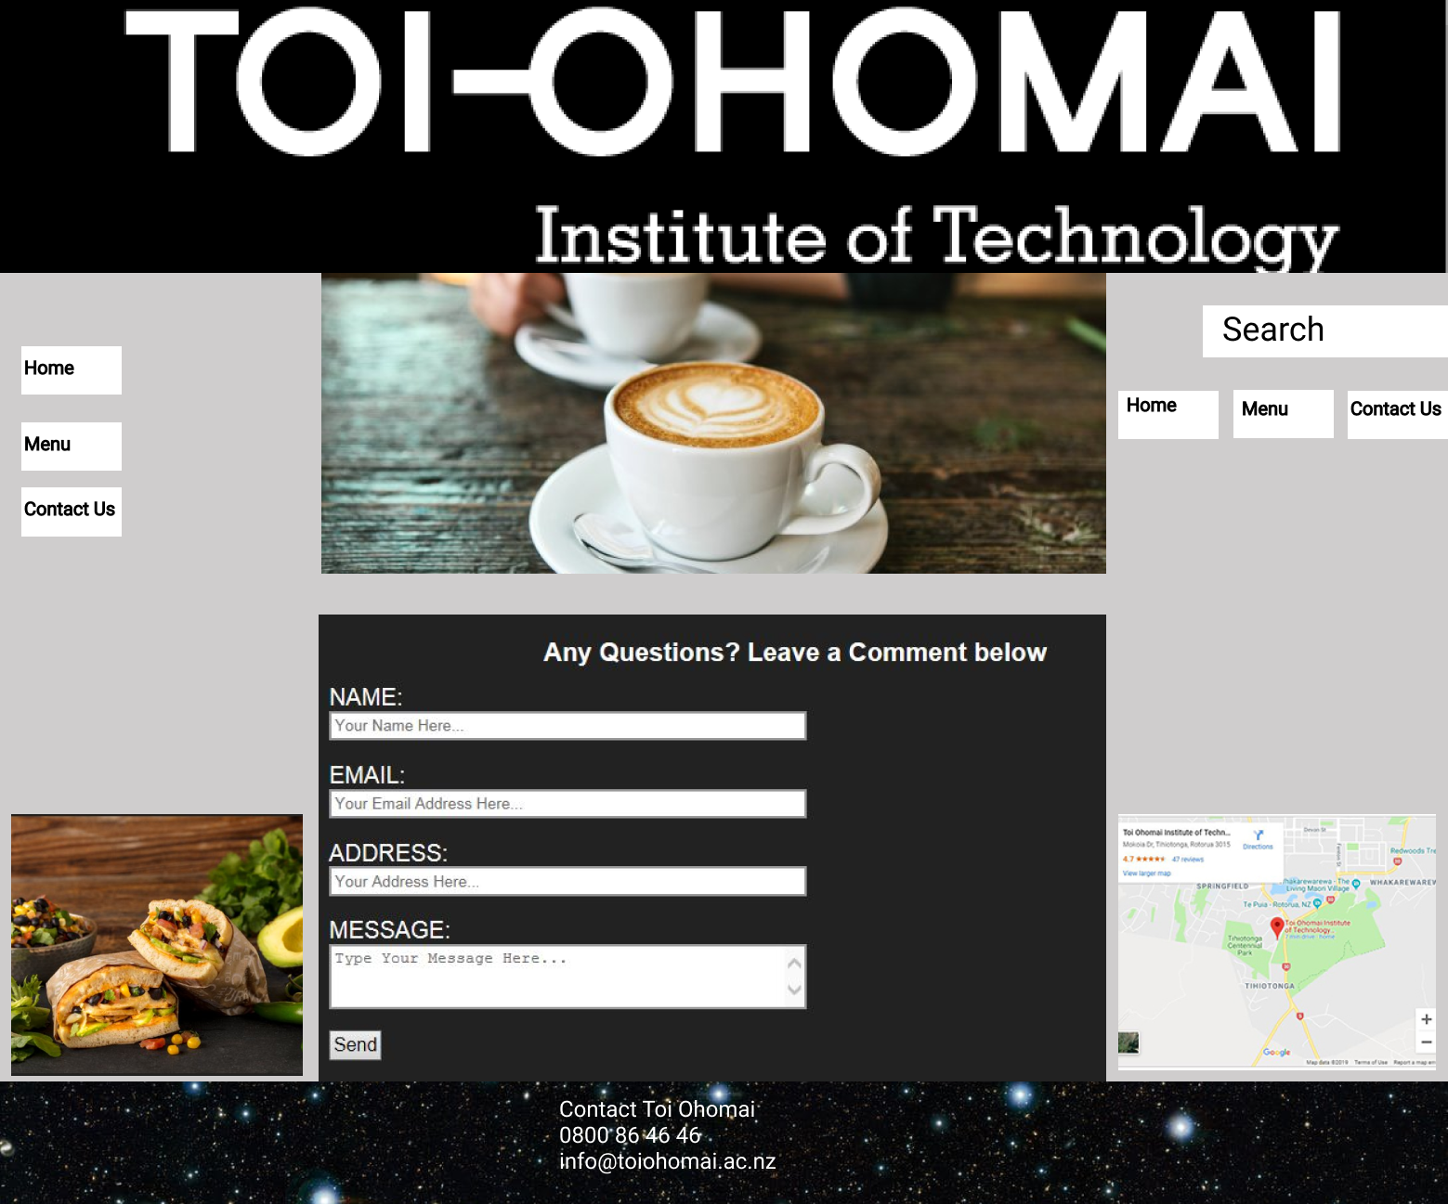

Menu - Desktop High- fidelity wireframe

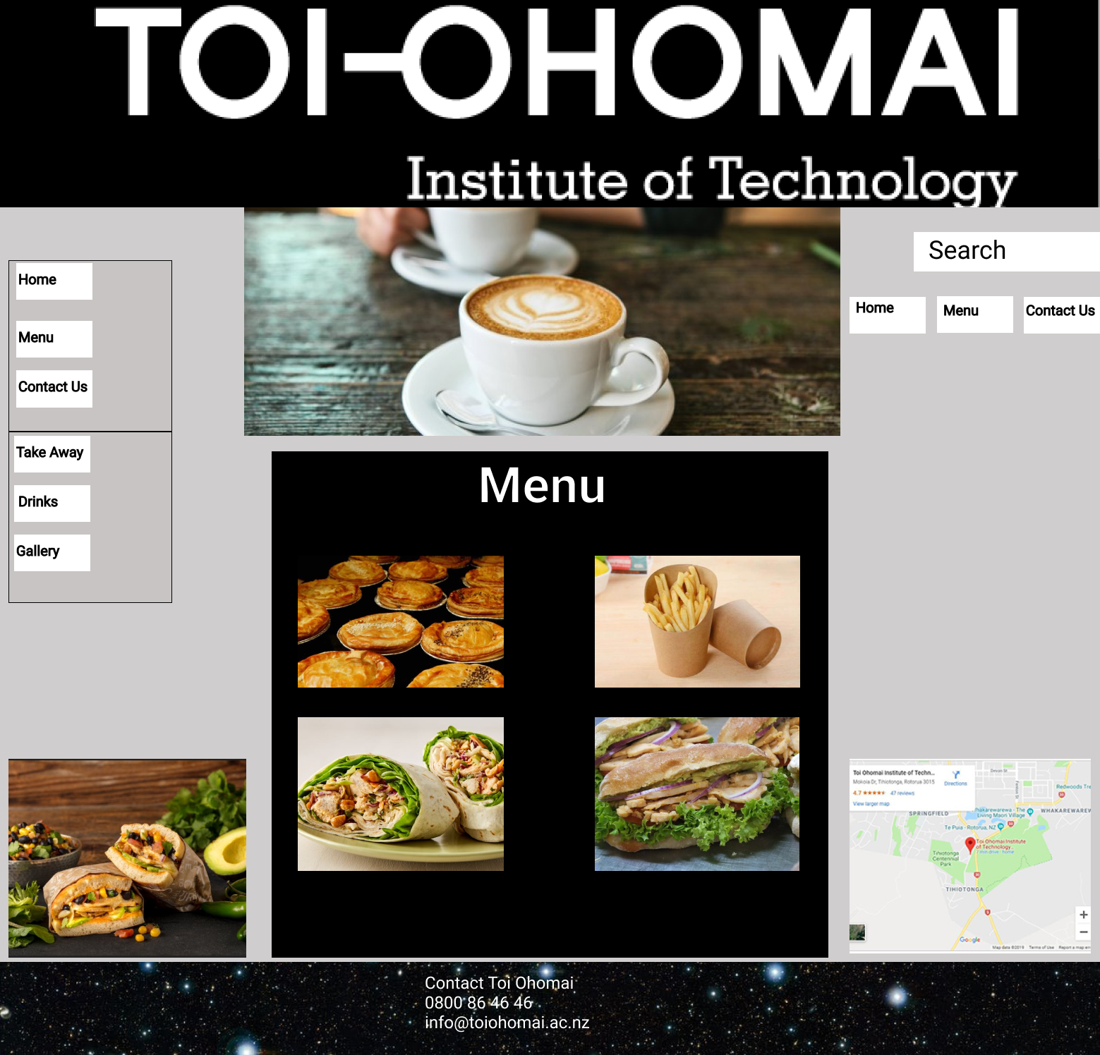

# Task 4: Storyboards (20 marks)

Create a storyboard for 2 sequences of events that can happen on your website. You will need to show the different screens to show the different steps. You are to show any feedback that is required for the user. i.e. If a mistake is made and the user needs to know about this, then the storyboard should reflect that.

# Task 5: Mood Boards (10 marks)

Create a mood board that includes all the colours, fonts and everything related to the “Look and feel” of the website. The mood board is to be included in the storyboard project. Any colours used for the high-fidelity wireframes and storyboards need to be included in the mood board. The colours chosen for this project are final and cannot be changed in the third assignment.

# https://lh6.googleusercontent.com/U_ekvhRybRTAjDQ1lLTQfYN6p6XbPGETh801pqmOCzXoKVpsY7MJhajrDdtqce3EqVVC03On1a_6JYHi1CCT-vu6eKXJUsv4D5WI6o0ijUlfZ6tTPW7mXvMEOK0m0icP-FDW58R1

# Task 6: Submission (10 marks)

All of your files must be exported as a Single PDF File and uploaded to Moodle.

Update your first assignment with the content of this assignment so that it becomes a single working document.

Name your files according to this format